Aetos Clinic AI
Project Proposal & Technical Architecture
An AI-powered clinic management platform for Indian OPD clinics, benchmarked against Arogyam.ai — including an evaluation of Bahmni as the backend.
Prepared for: Aetos Tech Labs
Date: 12 September 2026
Status: Draft v0.1 — for internal decision

Contents

1. Executive summary
Arogyam.ai is a subscription clinic-management SaaS for Indian doctors (₹1,099–₹2,699 per clinic per month, ex-GST). Its differentiator is not the EMR — it is a layer of nine AI “agents” (voice scribe, pre-visit intake, medication safety, smart queue, revenue integrity, follow-up engine, command centre, lab insights, patient concierge) sitting on a fairly conventional OPD workflow: registration, appointments/queue, encounter charting with 1-click templates, Indian drug database with ICD-10, billing with UPI/Razorpay, WhatsApp/SMS patient messaging, a patient portal/app, and ABDM readiness (ABHA linking, FHIR-shaped records, consent-based sharing).
This proposal describes how to build a comparable product, “Aetos Clinic AI”, and answers the specific question: should Bahmni be the backend?

Recommendation in one paragraph
Do not make Bahmni the backend of a multi-tenant clinic SaaS. Bahmni is an excellent single-facility hospital EMR/HMIS (OpenMRS + Odoo + OpenELIS + PACS), but it is architecturally the wrong shape for what Arogyam.ai is: a lightweight, multi-tenant, mobile-first OPD product sold at ₹1,000–₹3,000/month with AI in the critical path. Bahmni is single-tenant per deployment, Java/MySQL-heavy, its clinician UI is AngularJS mid-migration to React, and its licence is AGPL-3.0 (a MIT/MPL relicensing is on the 2026 roadmap but not done). Build a FHIR-native core of your own (roughly 8–10 well-scoped services on PostgreSQL) and reuse Bahmni selectively: its ABDM HIP/HIU services (BahmniIndiaDistro, M1–M3 complete) as the ABDM adapter, and its concept/drug/India master data as seed content. Keep a “Bahmni Lite headless” path open only if the target segment shifts to 20–100-bed hospitals with IPD, lab and pharmacy inventory — there Bahmni’s breadth becomes an asset rather than a burden.

Is the idea good?
Yes, with caveats. The market is real: ABDM adoption is pushing Indian clinics from paper to software, and clinics buy on price, WhatsApp-native workflows and time saved per consult. The AI scribe + follow-up engine is where the value and the moat is; the EMR/billing part is table stakes and heavily commoditised (Arogyam.ai, Practo Ray, HealthPlix, Eka Care, DocOn and many others). Aetos should win on (a) depth of Indian-language AI scribing, (b) reliability and offline tolerance in tier-2/3 clinics, (c) an ABDM implementation that actually works end-to-end, and (d) a channel — Aetos already sells hardware/automation to institutions, so bundled clinic kiosk + tablet + software is a plausible wedge. The risks are clinical safety of AI outputs, DPDP Act 2023 compliance, and the pure-price race in the SMB clinic segment.

2. Product scope — feature parity with Arogyam.ai
The table maps Arogyam.ai’s published capabilities to what Aetos Clinic AI ships, and in which phase. Phases are defined in section 7.
Capability (Arogyam.ai) | Aetos Clinic AI scope | Phase
Patient registration, ABHA link, demographics | FHIR Patient resource; ABHA create/verify via ABDM M1; QR scan; duplicate detection | MVP
Appointments, walk-in check-in, token queue | Slot engine, walk-in tokens, TV/queue display, doctor delay handling | MVP
Encounter charting, SOAP notes, 20+ OPD templates | Structured encounter (Condition/Observation/Procedure), 25 India OPD templates, custom template builder | MVP
Indian medication DB (2.5 lakh+), ICD-10 | Licensed/curated Indian drug master (brand→salt→strength), ICD-10 + SNOMED CT (free in India via NRC) | MVP
Prescription PDF, WhatsApp delivery | Rx template engine, clinic branding, WhatsApp Business API + SMS fallback | MVP
Billing, invoices, UPI/Razorpay, audit trail | Own billing service; GST invoices; Razorpay + UPI intent; immutable ledger | MVP
Patient portal / mobile app | Flutter patient app (Android first, iOS second); records, booking, payments | Phase 2
AI Scribe (voice → SOAP note, Hindi/Telugu/Tamil) | Streaming ASR (Indic models) + LLM structuring into FHIR; doctor approves before save | Phase 2
Pre-visit intake agent | WhatsApp conversational intake → vitals/symptoms pre-filled on encounter | Phase 2
Medication safety check | Rule engine (interaction/allergy/dose) + LLM explanation; rules are the source of truth, not the LLM | Phase 2
Smart queue (urgency triage) | Intake-driven triage score reorders queue; doctor override | Phase 3
Follow-up engine (chronic recalls) | Care-plan schedules → WhatsApp nudges → rebooking; reduces no-shows | Phase 2
Revenue integrity | Unbilled-procedure detection from encounter vs invoice diff | Phase 3
Lab insights, command centre, concierge | Lab PDF/HL7 ingestion + trend summaries; owner dashboard; patient FAQ bot | Phase 3
ABDM ready (HIP/HIU, consent) | Full M1–M3 via reused Bahmni HIP/HIU services or NHA ABDM-wrapper; real NHA sandbox certification | Phase 2
Security: ISO 27001, AES-256, India residency | India-region cloud, encryption at rest/in transit, audit log, DPDP consent registry; ISO 27001 programme in year 1 | MVP→ongoing
Multi-clinic / branches | Tenant → organisation → location hierarchy from day one | MVP (data model), Phase 3 (UI)

Deliberate non-goals for v1
- In-patient (IPD/wards/beds), OT scheduling, pharmacy inventory, PACS/imaging — these are where Bahmni shines and where Aetos should not compete initially.
- Insurance/TPA claims and NABH accreditation workflows.
- Autonomous clinical decisions. Every AI output is a draft that a licensed doctor approves; the product never prescribes.

3. Recommended architecture (build-your-own core)
The system is a modular monolith-to-services design: a small number of clearly bounded services, all speaking FHIR R4 internally where it matters (Patient, Encounter, Condition, Observation, MedicationRequest, Appointment, Invoice), an event bus for everything asynchronous (notifications, AI jobs, analytics), and a separate Python AI layer behind an LLM gateway so that models can be swapped and every AI call is logged, redacted and evaluated.
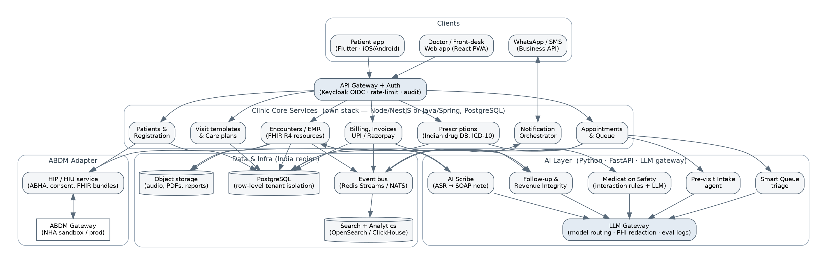
Figure 1 — Aetos Clinic AI target architecture

3.1 Components
Component | Responsibility | Notes
Doctor / front-desk web app | React + TypeScript PWA; works on laptops and Android tablets; offline queue for check-in and Rx when internet drops | Design system: Carbon or MUI; Hindi/Telugu/Tamil UI strings from day one
Patient app | Flutter; booking, records, payments, ABHA consent | Ship Android first (majority of Indian patients)
API gateway + auth | Keycloak (OIDC), per-tenant realms or a single realm with tenant claim; rate limiting; request audit | Same identity layer Bahmni is moving to — keeps the Bahmni path open
Clinic core services | Registration, Appointments/Queue, Encounters/EMR, Prescriptions, Billing, Templates/Care plans, Notification orchestrator | NestJS (TypeScript) or Spring Boot; one PostgreSQL cluster, row-level security by tenant_id
AI layer | Scribe, Intake, Medication Safety, Smart Queue, Follow-up/Revenue integrity; FastAPI workers consuming the event bus | Stateless; PHI redaction before any external model call; every prompt/response stored for eval
LLM gateway | Model routing (e.g. hosted LLM for structuring, Indic ASR for speech, small local model for classification), retries, cost caps, prompt versioning | Lets you switch between Google Vertex AI (what Arogyam uses), Anthropic, OpenAI, or on-prem models without touching product code
ABDM adapter | HIP + HIU: ABHA create/verify, care-context linking, consent handling, FHIR bundle generation, data push/pull via NHA gateway | Reuse Bahmni HIP/HIU services (BahmniIndiaDistro) or NHA’s ABDM-wrapper; wrap behind your own API
Data & infra | PostgreSQL (primary), object storage (audio, PDFs), Redis Streams/NATS event bus, OpenSearch or ClickHouse for analytics | India region (AWS Mumbai/Hyderabad, GCP Mumbai, or Indian provider); daily encrypted backups; per-tenant export

3.2 Data model and multi-tenancy
One PostgreSQL cluster, shared schema, tenant_id on every table, enforced by PostgreSQL row-level security policies bound to the JWT tenant claim. This is the cheapest model that still gives a hard isolation guarantee, and it is exactly what Bahmni cannot give you (one OpenMRS/MySQL per facility). Large customers who demand a dedicated database later can be moved to a dedicated schema without code change. Store clinical content as FHIR-shaped JSONB alongside relational indexes for the fields you query (patient, date, doctor, code). Keep an append-only audit table and an append-only billing ledger.

3.3 The AI layer — how each agent is built
Agent | Pipeline | Safety control
AI Scribe | Browser/mobile captures audio → streaming Indic ASR (e.g. AI4Bharat IndicConformer, Whisper-large fine-tune, or a hosted Indic ASR) → LLM structures transcript into SOAP + FHIR Condition/MedicationRequest drafts → doctor reviews diff view → save | Nothing is saved unmedited; drug names resolved only against the drug master; confidence flags on uncertain entities
Pre-visit intake | WhatsApp flow (buttons + free text) → LLM extracts complaints, duration, vitals → Observation drafts on the appointment | Red-flag symptom list escalates to staff, never auto-advises
Medication safety | Deterministic rule engine (interaction pairs, allergy, renal/paediatric dose ranges) on every Rx change; LLM only writes the explanation | LLM cannot suppress a rule hit; interaction DB licensed or curated
Smart queue | Intake-derived triage score + wait time → suggested order | Doctor/front-desk override always available
Follow-up engine | Care-plan rules per condition (e.g. diabetes 90-day review) → scheduled WhatsApp nudges → one-tap rebook | Opt-out per patient; DPDP consent recorded
Revenue integrity | Diff of procedures/observations in encounter vs invoice lines → “unbilled items” list | Suggestion only; no auto-billing

3.4 ABDM integration
ABDM has three milestones: M1 (ABHA creation/verification and linking), M2 (HIP — your clinic shares records to the patient’s PHR app with consent), M3 (HIU — you fetch the patient’s history from other providers with consent). Arogyam.ai only claims “ABDM-ready by design intent”; a working, sandbox-certified M1–M3 is a real differentiator. Two routes: (1) reuse Bahmni’s HIP/HIU services from BahmniIndiaDistro — they are already M1–M3 complete but assume OpenMRS as the record store, so you would adapt their data adapters to your FHIR store; (2) use NHA’s official ABDM-wrapper (Java) and write the HIP/HIU callbacks yourself. Either way the adapter lives behind your own API so the core never depends on it.

3.5 Security, privacy and compliance
- DPDP Act 2023: consent registry per patient per purpose (treatment, reminders, marketing), data-principal rights (access, correction, erasure), breach notification runbook, consent-manager readiness.
- Encryption: TLS 1.3 in transit, AES-256 at rest (cloud KMS), field-level encryption for ABHA numbers and phone numbers, per-tenant export keys.
- Audit: every read of a patient record is logged (who, when, why) — required for ABDM and expected by ISO 27001 auditors.
- AI governance: PHI redaction before external model calls, model/prompt versioning, human-in-the-loop on every clinical artefact, evaluation set of real (consented, anonymised) consults per language.
- Certifications: ISO 27001:2022 programme started in year 1 (Arogyam.ai advertises it; buyers ask). Avoid the “HIPAA-grade” marketing claim — HIPAA is not applicable in India and auditors dislike it.

4. Technology stack
Layer | Choice | Why
Web frontend | React 19 + TypeScript, Vite, PWA, TanStack Query | Largest hiring pool in India; PWA offline support
Mobile | Flutter | One codebase, good on low-end Android
Backend | NestJS (TypeScript) — or Spring Boot if the team is Java-first | Shares types with the frontend; fast to iterate
AI services | Python 3.12, FastAPI, LangGraph or plain orchestration, LiteLLM/own gateway | Ecosystem for ASR/LLM tooling
ASR / LLM | Indic ASR (AI4Bharat or hosted), hosted LLM via gateway; small local model for classification | Language coverage + cost control; swap without product change
Database | PostgreSQL 16 (RLS), Redis, object storage (S3-compatible) | Multi-tenant isolation, JSONB for FHIR
Events | Redis Streams (start) → NATS JetStream (scale) | Simple first, no Kafka ops burden
Identity | Keycloak (OIDC), WebAuthn for doctors | Standard; same direction as Bahmni/OpenMRS
Messaging | WhatsApp Business API (Meta Cloud API or BSP), SMS via DLT-registered provider | Indian DLT compliance is mandatory for SMS
Payments | Razorpay (UPI, cards), UPI intent links on invoices | Same as competitor; broad acceptance
Terminology | SNOMED CT (India NRC licence — free), ICD-10, LOINC; curated Indian drug master | Needed for ABDM FHIR profiles
Infra | Docker + Kubernetes (or Nomad) in an India region; Terraform; GitHub Actions; Grafana/Loki | Residency + repeatability

5. Bahmni as the backend — evaluation

5.1 What Bahmni is
Bahmni is an open-source hospital EMR/HMIS maintained by the Bahmni Coalition (originally Thoughtworks), recognised as a Digital Public Good and used at 500+ sites in 50+ countries. It bundles OpenMRS (clinical record, Java/MySQL), Odoo (billing and inventory, Python/PostgreSQL), OpenELIS (laboratory) and dcm4chee (PACS/imaging), glued together with Atom-feed based event synchronisation and an AngularJS/React clinician front end. Since 2023 there is “Bahmni Lite”, a Docker-packaged, cloud-ready profile aimed at clinics and small hospitals, shipped with India master data, and “BahmniIndiaDistro” which adds ABDM HIP/HIU services with milestones M1–M3 complete. The 2026 roadmap is migrating Angular modules to React (Carbon design system, aligned with OpenMRS O3), adopting Keycloak, moving to OpenELIS Global, and relicensing from AGPL-3.0 to MIT/MPL-2.0.
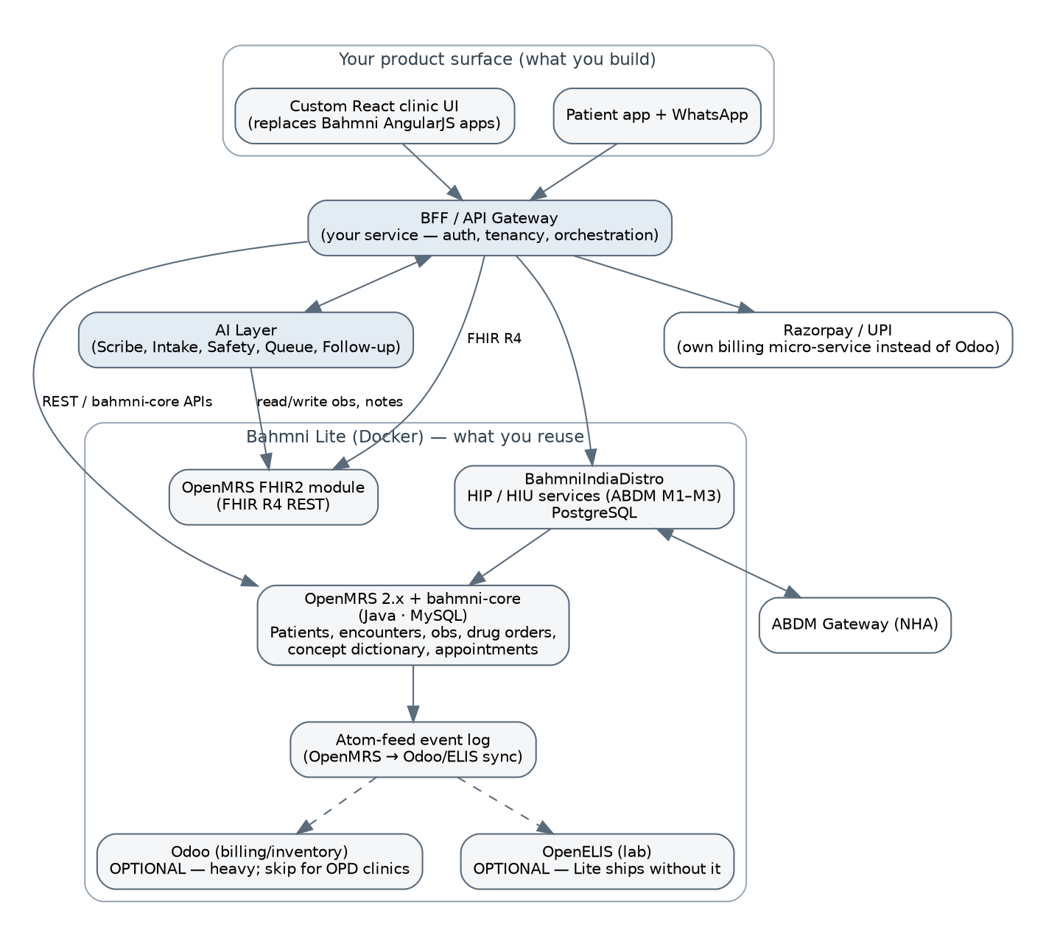
Figure 2 — How Bahmni Lite would sit under an Aetos product surface (headless pattern)

5.2 Pros
Advantage | What it means for Aetos
Mature clinical data model | OpenMRS’s patient/encounter/obs/concept model has 15+ years of production hardening; drug orders, allergies, diagnoses, visits, programs are all there.
ABDM M1–M3 already done | BahmniIndiaDistro HIP/HIU services are the most complete open-source ABDM implementation available — months of NHA sandbox work already paid for.
India master data | Bahmni Lite ships India-specific concepts, forms, address hierarchy and drug lists — a real head start over an empty schema.
FHIR R4 out of the box | OpenMRS FHIR2 module exposes standard resources, so your AI layer and patient app can be FHIR-native either way.
Breadth for hospitals | IPD, wards, OT, pharmacy inventory, lab, imaging exist. If a customer grows from clinic to 50-bed hospital you don’t rebuild.
Dockerised, cloud-ready | bahmni-docker brings up Lite or Standard with compose; reasonable for single-facility hosting.
Community and vendors | Active Slack/Talk community, Indian implementers (Nuchange, Thoughtworks alumni) — support and hiring exist.
Zero licence fee | No per-seat cost; keeps unit economics at the ₹1,000/month price point feasible on the software side.

5.3 Cons
Drawback | Impact on an Arogyam-style SaaS
Single-tenant by design | One OpenMRS + MySQL (+ Odoo/Postgres) per facility. To host 1,000 clinics you run 1,000 stacks or hack tenancy into OpenMRS — neither is cheap. This alone breaks the ₹1,099/month economics.
Heavy footprint | A Lite stack needs roughly 4–8 GB RAM per deployment; Standard (with Odoo, ELIS, PACS) far more. Arogyam-class products run thousands of clinics on a shared cluster.
UI is not yours | Clinician UI is AngularJS (legacy) with React migration in progress; it is a hospital-desk UX, not a 2-minute-per-patient OPD UX. You will replace it anyway — the diagram above assumes that.
Java/MySQL + Odoo/Python + Atom-feed sync | Three runtimes, two databases, eventual-consistency glue. Debugging cross-component issues is a known pain point in the Bahmni community.
AGPL-3.0 licence (today) | AGPL obliges you to publish source of modified Bahmni components you run as a network service. Your own separately-written services talking over APIs are generally not affected, but any custom module inside OpenMRS/Bahmni is. Relicensing to MIT/MPL is on the 2026 roadmap — not yet shipped. Get legal review.
Odoo billing is over-engineered for OPD | Odoo Community brings ERP complexity, upgrade friction, and no native Razorpay/UPI flow. You would write your own billing service regardless.
Upgrade risk | Bahmni releases roll OpenMRS core, modules, Odoo and ELIS versions together; upgrades of customised installs are a multi-day exercise.
AI is a bolt-on | No event streaming, no job queue, no LLM plumbing; everything AI must be built as an external system reacting to Atom feeds or polling FHIR.
Performance and reporting | OpenMRS obs table grows fast; cross-clinic analytics needs an extra warehouse (Bahmni uses separate reports DB/Metabase).

5.4 Verdict and decision rule
If your target customer is… | Then…
Single-doctor and small multi-doctor OPD clinics at ₹1–3k/month, thousands of tenants, mobile/WhatsApp-first, AI in the loop (the Arogyam.ai segment) | Build your own core (section 3). Reuse Bahmni’s ABDM services and master data. Do not deploy OpenMRS/Odoo per clinic.
Nursing homes and 20–100-bed hospitals that need IPD, lab, pharmacy inventory, imaging; tens of customers; willing to pay ₹15k+/month or a project fee | Bahmni Lite/Standard headless, one stack per hospital, your React UI + AI layer on top (Figure 2). Aetos’ hardware/automation background fits this segment’s on-prem needs well.
Both | Own core for clinics; Bahmni per-hospital for institutions; the same AI layer and patient app talk to both through FHIR R4. This is why the core must be FHIR-native.

Practical middle path: stand up Bahmni Lite in Docker in week 1 as a reference — study its India concept dictionary, drug master, OPD forms and the ABDM services — and use that as the specification for your own schema and adapter. That captures most of Bahmni’s knowledge without inheriting its runtime.

6. Option comparison
Criterion | A. Own FHIR-native core (recommended) | B. Bahmni Lite headless | C. Bahmni as-is + custom modules
Time to MVP (OPD clinic) | 4–5 months | 3–4 months (faster start, slower finish) | 2 months, but UX is Bahmni’s
Multi-tenant SaaS economics | Excellent | Poor (stack per clinic) | Poor
AI integration effort | Native (event bus, FHIR JSONB) | Medium (external, FHIR2 + Atom feeds) | High
ABDM | Reuse Bahmni HIP/HIU or NHA wrapper | Included | Included
IPD / lab / pharmacy / PACS | Not in v1 | Available | Available
Licence exposure | Only your code; permissive libs | AGPL on Bahmni parts; own services clean if API-separated | AGPL on all customisations
Ops complexity | Low–medium | Medium–high | High
Long-term control of UX/roadmap | Full | Full on UI, dependent on backend | Low
Best fit | Clinic SaaS (Arogyam segment) | Hospitals/institutions | NGO / single hospital pilot

7. Delivery plan

7.1 Phases
Phase | Duration | Deliverables | Exit criteria
0 — Discovery & foundations | Weeks 1–4 | Bahmni Lite reference install; 10 clinic interviews; FHIR profile decisions; drug master sourcing; DPDP consent design; infra/Terraform; CI; Keycloak; design system | Signed-off scope, schema v1, working skeleton with auth + tenancy
1 — MVP OPD | Weeks 5–20 | Registration, appointments/queue, encounter + templates, Rx with drug master and PDF, billing + Razorpay, WhatsApp/SMS reminders, owner dashboard, ABHA M1 | 5 pilot clinics live; <2 min per consult for templated visits; zero data-loss incidents
2 — AI + ABDM | Weeks 21–36 | AI Scribe (Hindi + Telugu + English), pre-visit intake, medication safety rules, follow-up engine, patient app (Android), ABDM M2/M3 sandbox certification | Scribe accepted without edits on ≥70% of consults in pilot; ABDM sandbox pass
3 — Scale & monetise | Weeks 37–52 | Smart queue, revenue integrity, lab insights, multi-branch UI, iOS app, ISO 27001 audit, self-serve onboarding (<48 h), pricing tiers | 100 paying clinics; churn <3%/month; ISO 27001 certified

7.2 Team
- 1 product lead / clinical domain owner (a practising doctor as paid advisor is strongly recommended).
- 2 backend engineers (TypeScript or Java), 1 frontend engineer (React), 1 Flutter engineer (from Phase 2).
- 1 AI/ML engineer (ASR + LLM pipelines, evaluation), 1 DevOps/security engineer (part-time until Phase 3).
- 1 QA with healthcare workflow experience; 1 implementation/onboarding specialist per ~50 clinics.

7.3 Indicative budget (rough order of magnitude)
Item | Year-1 estimate (INR) | Basis
Engineering team (6–7 FTE, India) | ₹1.6–2.4 crore | ₹20–35 lakh per engineer-year blended
Cloud (India region) at 100–500 clinics | ₹15–30 lakh | Shared cluster; AI inference dominates
AI/ASR API costs | ₹8–20 lakh | Depends on scribe adoption; ~₹5–15 per scribed consult at current hosted rates
Drug/interaction database licence | ₹5–15 lakh | Or curate own from CDSCO/open sources at higher effort
WhatsApp/SMS | ₹5–10 lakh | Utility templates ~₹0.12–0.30/message
ISO 27001 + legal (DPDP, AGPL review) | ₹8–15 lakh | Consultant + auditor + counsel
Total | ≈ ₹2.1–3.5 crore | Excludes sales/marketing

Unit economics sanity check: at ₹1,599/month a clinic yields ~₹19k/year. Break-even on the year-1 build needs roughly 1,100–1,800 paying clinics — which is why the hospital/institution segment (higher ARPU, Bahmni-based) is worth keeping as a parallel revenue line rather than a distraction.

8. Key risks and mitigations
Risk | Mitigation
AI scribe produces wrong drug/dose | Drug entities resolved only against the master; doctor sign-off mandatory; confidence flags; per-language eval set; incident log
Indic ASR accuracy in noisy clinics | Directional mic hardware bundle (Aetos strength); domain fine-tuning; fall back to typed templates
DPDP Act enforcement / data breach | Consent registry, encryption, audit, breach runbook, India residency, minimal PHI to external models
ABDM spec churn | Isolate behind adapter; track NHA releases; reuse community (Bahmni/NHA wrapper) rather than own gateway code
Price war in clinic SaaS | Differentiate on scribe quality + hardware bundle + institution channel; avoid feature-parity race
AGPL contamination if Bahmni code is reused | Keep Bahmni services in separate containers behind APIs; publish modifications to those services; legal review before launch
Scope creep toward hospital features | Non-goals list enforced; hospital demand routed to the Bahmni-headless line

9. Decisions needed and next steps
- Confirm target segment for v1: OPD clinics (recommended) vs hospitals — this fixes the Bahmni decision.
- Choose backend language (TypeScript/NestJS vs Java/Spring) based on the team you can hire.
- Pick LLM/ASR providers and confirm India data-residency terms in writing.
- Source the Indian drug master and interaction database (licence vs curate).
- Week 1: bring up Bahmni Lite + BahmniIndiaDistro in Docker as the reference; extract concept dictionary and ABDM flows.
- Week 2–4: clinic interviews, FHIR profiles, schema v1, infra skeleton; then start Phase 1.

Sources
- Arogyam.ai — product site: https://arogyam.ai/ and https://arogyam.app/
- Arogyam.ai — ABDM-ready clinic software page: https://arogyam.ai/abdm-software
- Bahmni — official site: https://www.bahmni.org/
- Bahmni — Architecture, RPMs and services: https://bahmni.atlassian.net/wiki/spaces/BAH/pages/114316310
- Bahmni — Roadmap and 2026 priorities: https://bahmni.atlassian.net/wiki/spaces/BAH/pages/3336896578
- Bahmni — Bahmni as Health Information Provider (ABDM): https://bahmni.atlassian.net/wiki/spaces/BAH/pages/2901114904
- Bahmni — Running Bahmni with ABDM on Docker: https://bahmni.atlassian.net/wiki/spaces/BAH/pages/3148087297
- Bahmni GitHub organisation: https://github.com/bahmni ; BahmniIndiaDistro: https://github.com/bahmniindiadistro
- NHA ABDM-wrapper: https://github.com/NHA-ABDM/ABDM-wrapper

